Guided Lab 330.2.1 - Basic Example for Correlation Coefficient and Covariance

Learning Objectives:
By the end of this exercise, learners will be able to:
- Calculate covariance and correlation to understand the direction and strength of relationships.
- Interpret the relationship between two variables using statistical measures such as covariance and correlation coefficient.
- Explain the significance of positive and negative correlations in context.
- Evaluate their findings through visual representations to determine the strength and direction of the relationship.

Lab Overview:
This lab will demonstrate and illustrate how to calculate and interpret covariance and correlation coefficients to understand relationships between variables. By examining the relationship between temperature and ice cream sales, we will:
- Calculate Means: Find the average values for both temperature and ice cream sales, which serve as baselines to assess how each data point deviates from the mean.
- Compute Covariance: By multiplying the deviations for each day and dividing by the number of data points, we will determine a positive covariance, indicating that higher temperatures tend to be associated with higher ice cream sales.
- Calculate Standard Deviations: The standard deviations will help quantify the typical spread from the mean for each variable, which is essential for standardizing covariance.
- Derive the Correlation Coefficient: By dividing covariance by the product of the two standard deviations, we will obtain a correlation coefficient close to +1, signifying a nearly perfect positive linear relationship between temperature and ice cream sales. This strong positive correlation means that as temperatures increase, ice cream sales reliably increase as well.
- Visualization: The scatter plot and trend line will visually confirm the strong positive association, with data points closely following a linear trend.

Scenario:
A good example of a correlation coefficient and covariance is looking at the relationship between ice cream sales and temperature: When the temperature increases (variable X), ice cream sales also tend to increase (variable Y), resulting in a positive covariance and a positive correlation coefficient, which means that the two variables move in the same direction; conversely, if you were to compare ice cream sales to umbrella sales, the correlation would be negative, as higher temperatures lead to lower umbrella sales, demonstrating a negative covariance and correlation coefficient.
We want to understand the relationship between two variables:
- Temperature (X): As the temperature rises, people are more likely to buy ice cream.
- Ice Cream Sales (Y): Higher ice cream sales are expected on hotter days.
This scenario is a great example of showing positive covariance and correlation because both variables tend to move in the same direction.
Key points about covariance and correlation coefficient:
Covariance tells us the direction of the relationship between temperature and ice cream sales.
- Positive covariance: If the temperature increases and sales increase, this suggests the two variables move in the same direction.
- Negative covariance: If we compared ice cream sales with something like umbrella sales, we might see a negative covariance (higher temperatures usually mean fewer umbrellas are sold).
Correlation Coefficient: This is a standardized version of covariance that ranges from:
- -1: Perfect negative correlation (when one variable goes up, the other goes down).
- +1: Perfect positive correlation (both variables increase or decrease together).
- 0: No correlation (the variables are independent of each other).

Given Dataset:
Imagine that you have data on daily temperature (X) and ice cream sales (Y) for three days:
Day | Temperature (X̄) | Ice Cream Sales (Ȳ
Day 1 | 20 | 100
Day 2 | 25 | 120
Day 3 | 15 | 80

Calculate the Covariance:

Step 1: Calculate the Means (Averages):
Let’s find the average temperature (X̄) and average ice cream sales (Ȳ)
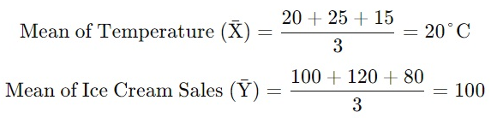

Avg Temp (X) = (20+25+15)/3 = 60/3 = 20 C

Avg Ice Cream Sales (Y) = (100+120+80)/3 = 300/3 = 100 C

Step 2: Calculate Deviations from the Mean of X and Y:
- Find the Deviations for each Data Point and calculate the deviation from the mean for both temperature (X - X̄) and ice cream sales (Y - Ȳ).
Temperature Deviations:
- Day 1: X1−X̄ → 20−20 = 0
- Day 2: X2−X̄ → 25−20 = 5
- Day 3: X3−X̄ → 15−20 = −5

Ice Cream Sales Deviations:
- Day 1: Y1−Ȳ → 100−100 = 0
- Day 2: Y2−Ȳ → 120−100 = 20
- Day 3: Y3−Ȳ → 80−100 = −20

Step 3: Multiply Deviations and Calculate Covariance of X and Y:
Multiply the deviations for each day, sum them up, and then divide by the total number of data points N:
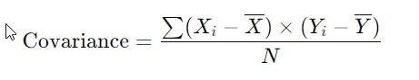
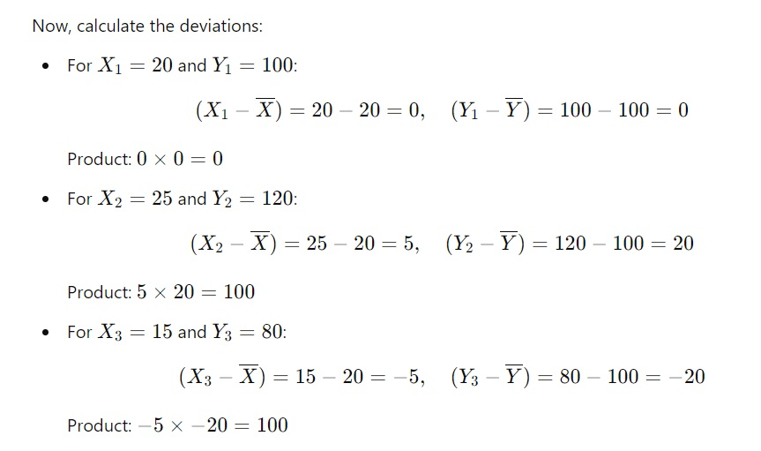
Finally, sum the products:
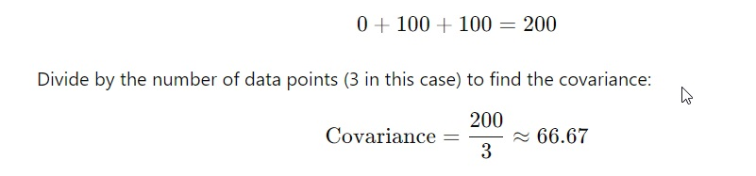
The positive covariance indicates that as temperature increases, ice cream sales also increase.

Step 4: Calculate the Correlation Coefficient:
To get the correlation coefficient (a standardized measure of covariance):
- Standard Deviations of X and Y: Calculate the standard deviation of temperature (X) and ice cream sales (Y) to understand how much each variable deviates from its mean.
- Divide Covariance by Product of Standard Deviations:
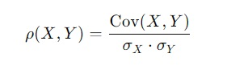
Where σX and σY​ are the standard deviations of temperature and ice cream sales, respectively.
This process yields a correlation coefficient between -1 and +1, giving us a clearer sense of the strength of the relationship where:
- +1 represents a perfect positive relationship.
- -1 represents a perfect negative relationship.
- 0 indicates no linear relationship.

4.1 - Square Each Deviation
Square each deviation to avoid negative values canceling out positive values:
- Temperature Deviations Squared:
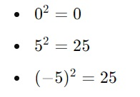
- Ice Cream Sales Deviations Squared:
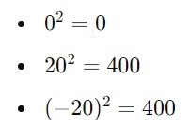

4.2 - Calculate the Mean of the Squared Deviations
This `mean` is the variance. Sum the squared deviations and divide by the number of data points (n = 3):
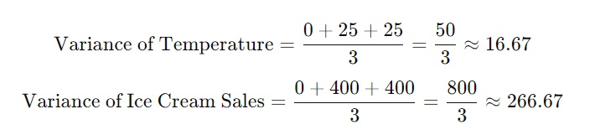

4.3 - Take the Square Root of the Variance to Get the Standard Deviation
Finally, take the square root of each variance to get the standard deviation:
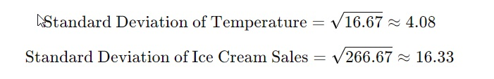

These standard deviations give us an idea of the typical distance from the mean for each variable, showing how much temperature and ice cream sales vary around their respective averages.

Visualization of Temperature and Ice Cream Sales
Here is the graph showing temperature and ice cream sales over three days. The dashed lines represent the mean values for each variable:
- Temperature values are marked with circles, and the mean temperature is indicated by the blue dashed line.
- Ice Cream Sales values are marked with squares, and the mean sales are represented by the orange dashed line.

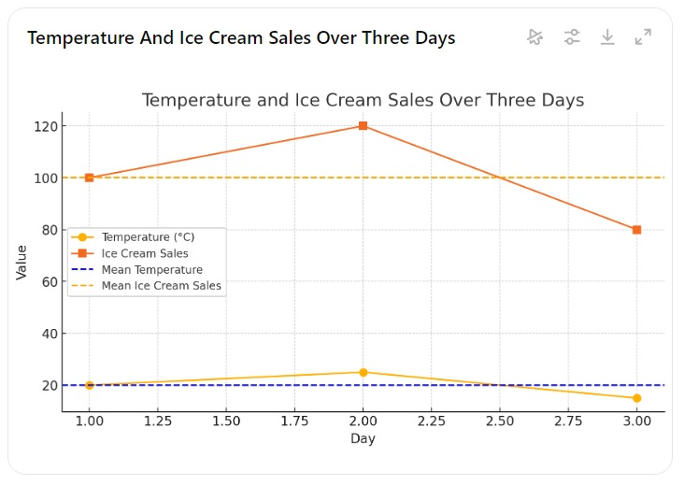

4.4 - Add Values to Correlation Coefficient Formula:
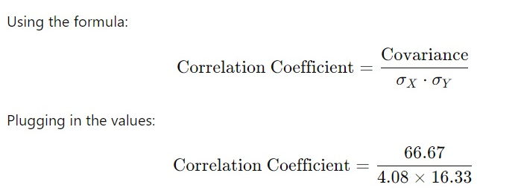

Calculation Result:
- After calculating this division, we arrive at a value of 0.9999999999999998, which rounds to +1.
This value close to +1 signifies a very strong positive relationship, where increases in temperature are strongly associated with increases in ice cream sales.

Here is the plot showing the relationship between temperature and ice cream sales:
- Data Points: Represent the temperature and ice cream sales for each day.
Day | Temp (X) | IC Sales (Y) | X - X̄ | Y - Ȳ | (X - X̄)² | (Y - Ȳ)² | (X - X̄)*(Y - Ȳ)
1 | 20 | 100 | 0 | 0 | 0 | 0 | 0
2 | 25 | 120 | 5 | 20 | 25 | 400 | 100
3 | 15 | 80 | -5 | -20 | 25 | 400 | 100
Covariance | 66.66666667
Variance X | 16.66666667
Variance Y | 266.6666667
SD X | 4.082482905
SD Y | 16.32993162
Correlation Coefficient | 1
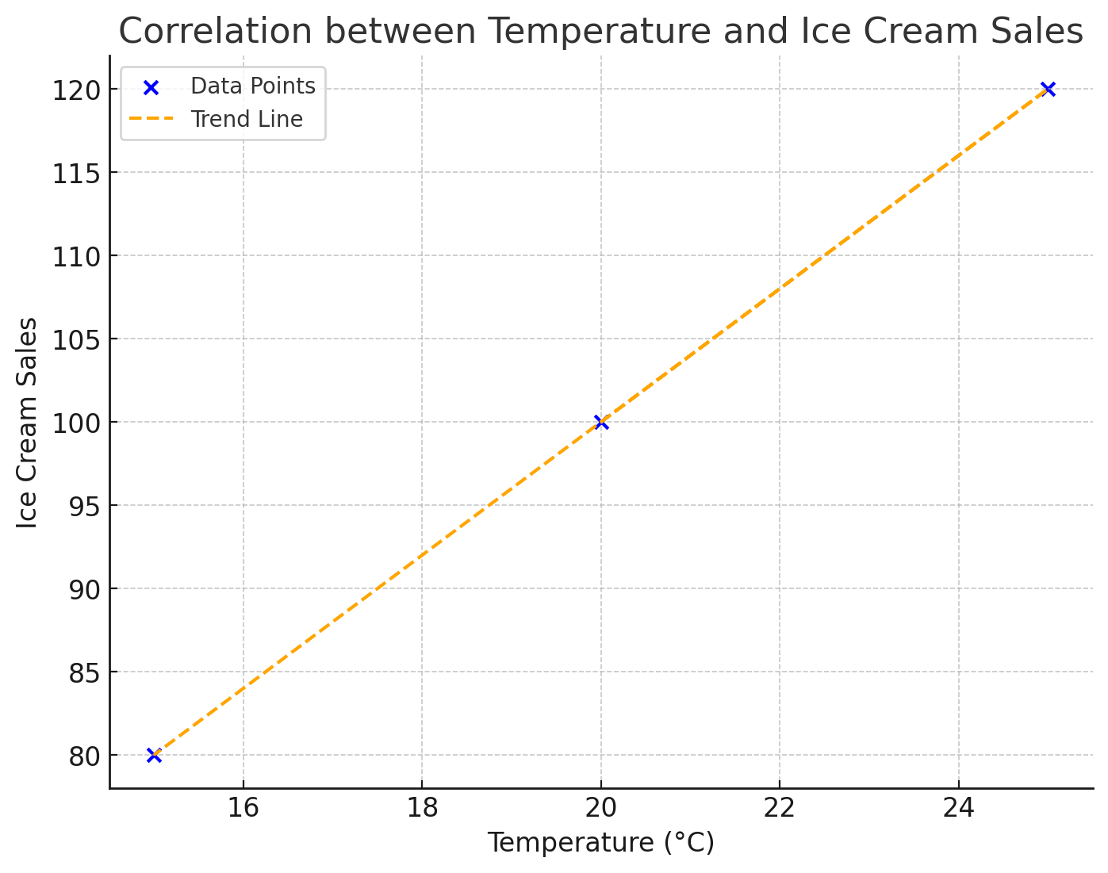
This linear pattern aligns with the high correlation coefficient, reflecting a strong positive relationship between the two variables.

Key Takeaways
- Covariance helps determine whether two variables move together, while correlation standardizes this relationship, making it easier to compare across datasets.
- A correlation coefficient near +1 or -1 indicates a strong relationship; here, a value near +1 confirmed that temperature increases lead to higher ice cream sales.
- Visualization aids in understanding the relationship by providing a visual check of the trend.
This lab demonstrates the utility of these statistical measures for exploring and confirming relationships, which is especially useful in fields such as sales forecasting and data-driven decision-making.

Canvas submission Instructions:
- Upload your project to your GitHub account without setting it to private.
- Utilize the `README` file for any necessary additional instructions.
- Incorporate suitable comments throughout your project.
- Share the GitHub link on Canvas by clicking on the "Start Assignment" button located in the top-right corner of the Assignment page.

